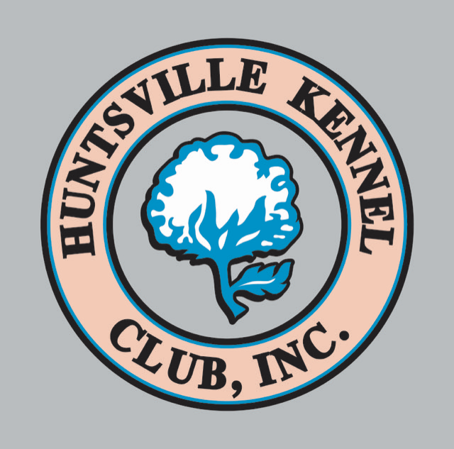
HUNTSVILLE KENNEL CLUB
wants your puppies!!!!
AKC Sanctioned All Breed Conformation B Match
Sunday August 11, 2024
Registration will begin @ 10:00 thru 11:30 AM
Match will begin @ NOON
Indoors / Air Conditioned / 2 Rings
RIBBONS! TROPHIES! BPIM! BAIM! BEST JUNIOR!
Pee Wee offered!!
Judges are Dawn Garbett, John Albert Brown & Ellie Kidd
Dawn Garbett: Sporting; Working; Toy; Misc & FSS
John Albert Brown: Hounds; Terriers; Non-Sporting; Herding
Ellie Kidd: Junior Showmanship & Pee Wee
Decatur Alabama Kennel Club Building
212 Mills Road SW, Decatur, AL 35603
Entries $10.00 per class for conformation: Day of Match entries only
$7.00 per additional entry, $5.00 per Junior Showmanship entry
Adult Classes: Open
***Major Pointed Dogs For Exhibition Only***
Professional Handlers are limited to handling their own dogs unless Exhibition Only
No grooming (trimming, chalking, spraying, etc.) inside building! Thank you!
Match Secretary: Jean M. Hairston
Phone: 256-345-1526 Email: hkckennelclub@gmail.com
We are offering Microchipping with lifetime registration at the match:
Cost: $25 per dog

